

Questionnaire and analysis:
service offered to community-led planning groups in South Oxfordshire and Vale of White Horse

introduction
To assist local communities in developing their questionnaires as part of the community-led planning process, South Oxfordshire and Vale of White Horse district councils offer a limited service to assist with questionnaire design, scanning and analysis.

The Oxfordshire Rural Community Council (ORCC) offers guidance, advice and support for drafting or creating questions and questionnaires. Visit www.oxonrcc.org.uk for more information about how ORCC may be able to support your group.

Snap is the name of the computer software used by the council to automate consultation processes. Further information and details of the service we offer are set out below.

Service overview
We offer a scanning service of questionnaires (surveys) to help community-led planning groups to manage their household questionnaire process through our automated survey software (Snap). This involves:
- setting up the questionnaire on Snap on behalf of the community-led planning (CLP) group
- publishing and calibrating the survey so that when completed surveys are scanned, Snap can detect ‘tick box’ responses and create data records from this
- scan completed surveys
- provide tables of results

General
- We can provide this service for up to two CLP groups to start each quarter. We define these quarters as April – June (quarter one), July –September (quarter two), October – December (quarter three), January – March (quarter four).
- You must contact us to book the service as soon as possible and at least one quarter in advance, so for instance, if you want to use the service in quarter two, you need to contact us to book a slot as early in quarter one as possible. Support is booked on a first come first served basis, and we cannot guarantee that the service will be available at the time of your choice.
- All stages of the service we provide to you must begin within the first month of the first quarter for which you have booked the service, and be finished no later than the last month of the following quarter. In practice, this means that you will need to provide your finalised questionnaire to us to set up on Snap during the first part of the first quarter; your questionnaire should be printed, distributed, and completed questionnaires collected and returned to us no later than the end of the first quarter. During the second quarter we will scan your questionnaires and produce data tables. If slippage occurs and completed questionnaires are not returned to us for scanning by the end of the first quarter, scanning and data tables may be significantly delayed.
- Please confirm as soon as possible how many questionnaires you expect to receive, and when they will reach the council offices so that we can allocate our resources accordingly.
- If we are unable to offer this service you may be able to arrange for this service through one of the companies listed in Appendix 3.

Questionnaire layout
We will:
- Set up your questionnaire on Snap using the version supplied by you. This should be the final version agreed by your group. Your questionnaire can be provided in Word or Excel format. There is no need to include tick boxes – we only need to know the questions.
- Produce a single respondent or single respondent household questionnaire
- Produce an A4 questionnaire containing a maximum of 65 questions and which does not exceed 10 sides.
- Only set up in Snap questions for which responses will form part of the data for analysis. i.e. we will not set up covering letters, frequently asked questions, contact/volunteer pages etc.
- Offer a range of question formats including multiple choices, grid questions and open text questions (please see notes on analysis below). Examples of the question types are in the Appendix.
- Set Snap up to accept multiple or single answer responses in line with your instructions, which should be marked on the questionnaire you supply to us.
- Provide you with a pdf file of the questionnaire to check for errors and make any corrections identified.
- We will calibrate the version of the questionnaire that we provide to you as the final version and run some test scans to ensure that the completed questionnaires that you return to us can be successfully scanned (see sections on printing and scanning, below).

We cannot:

- Make changes to questionnaires set up in Snap apart from correcting errors and making minor changes to layout due to differences created by Snap. It is, therefore, important that everyone in your group has agreed and is happy with the questions, wording and punctuation before it is sent to us.
- Include images in the questionnaire, for example maps, logos, diagrams or photographs.
- Produce multi-respondent questionnaires
- Set up covering letters, contact details sheets and volunteer pages in Snap – you will need to produce these separately from the questionnaire

Printing
We will provide your questionnaire in a pdf format for printing and will provide instructions for printing. Questionnaires can be printed single sided OR double sided. However, there are some general points to bear in mind.

It is essential that:

- Printing is done direct from the pdf file either through a digital printing process or through litho printing from a plate created from the file provided. (Photocopies or questionnaires printed using a home printer will not be accepted by the scanner.)
- Questionnaires are collated using a single staple in the top left hand corner.
- Questionnaires are all printed at the same time, on the same machine to ensure accuracy in the page layout
- Three blank copies of the printed questionnaire are provided to us as soon as possible. This enables us to recalibrate should the printing of the questionnaire have resulted in some slight differences to the position of the questionnaire on the page.

Please note: the questionnaire must not be photocopied as this can result in each copy of the questionnaire being in a slightly different position on the page so that scanning is not possible.

We cannot:

- Print your questionnaire for you.
- Proceed with data input if the printing process used means that the questionnaires cannot be scanned.

Scanning and data analysis
We will:

- Scan in all completed questionnaires returned to us. Questionnaires should be delivered to the council offices (either South Oxfordshire or Vale of White Horse), preferably in batches as they are returned to you.
- Manually input questionnaires which will not scan for reasons other than the printing process used, for example, a badly crumpled questionnaire, a questionnaire spoiled by spillage. However, we can only manually input up to 2% of the total number of completed questionnaires and will contact you to discuss if this problem arises.
- Provide results for tick box questions only
- Provide a set of top-line results showing the counts and percentages for each response
- Provide a table of responses for each question showing baseline, total responses, number and percentage response for each variable. Where possible, we will include a breakdown of these results by age and gender.
- We can produce up to an additional 5 tables of data at your request, for example one question analysed by another question. Some examples are in the Appendix.
- Keep your data confidential and ask your permission to share the results with officers within the council or other parties if we receive a request.

We cannot:
- Analyse open ended/text questions. This will need to be undertaken manually by your group
- Provide, charts, graphs etc. of results
- Provide a commentary on, or interpretation of the tables of data, nor make recommendations on the basis of the results of the table
- Store your paper questionnaires following scanning.

More information
For more information about the South Oxfordshire and Vale of White Horse District Councils SNAP service and to book a time slot for your questionnaire layout, scanning and analysis, please contact
Anne Richardson, Shared Corporate Projects Officer
01491 823311 / 01235 540352
anne.richardson@southandvale.gov.uk

More examples of questionnaire styles and types can be found on the Community Led Plans South East website: www.clp-se.org.uk

Appendix 1
Examples of question types produced by SNAP: The following questions are an excerpt taken from the Drayton St Leonard village community plan questionnaire.

Appendix 2
Example of results tables of data produced by SNAP service: the results table shows how each question can be broken down as appropriate – this one is broken down by age and gender.

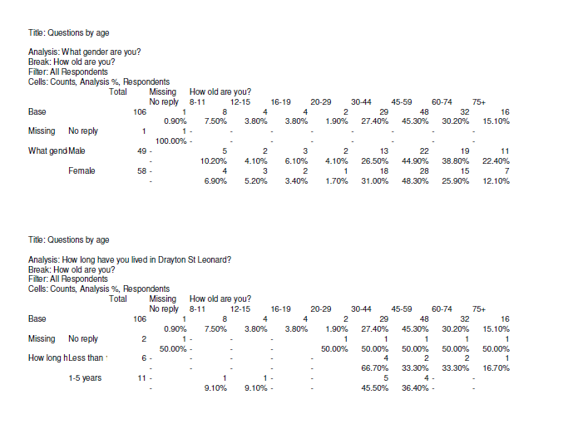

Appendix 3
Please find details of four companies below who could be contacted to provide quotes to get support for surveys. Of the four the district council has direct experience of the snap survey service, however the others may be as good quality and potentially lower cost.

Useful reminders for parishes
- It is often cheaper to get a quote before carrying out the survey as they can advise on survey format to keep costs low
- They may be able to set up an online questionnaire at no additional cost or low cost
- If the questionnaire collects residents names/ addresses they should state somewhere on it that responses will be processed by a third party
- The outputs they will need are a copy of the marked up questionnaire showing overall results and data tables showing results by sub group eg men vs women, different age groups, ethnic groups, people with disabilities, people living in specific areas etc
- If they want a report explaining the results this will be extra

Snap surveys
http://www.snapsurveys.com
researchservices@snapsurveys.com
01454 280810

Cleardata entry
http://www.ukdataentry.com/Data-Entry-Services-Prices.htm
enquiries@cleardata.co.uk
0800 046 8083
Direct data company (based Banbury)
http://www.directdatacompany.co.uk/
info@directdatacompany.co.uk
01295 277266
QPSMR (based Wallingford)
http://www.qpsmr.org.uk/
info@qpsmr.ltd.uk
01491 825644

Vale of White Horse District Council, Abbey Close, Abingdon, OX14 3JE www.whitehorsedc.gov.uk  South Oxfordshire District Council, Benson Lane, Crowmarsh Gifford, Wallingford, OX10 8AX www.southoxon.gov.uk |  | 

